Database assessment :

Crete database name as products:

1. This is the query for database

Create database products;

1. Creating table

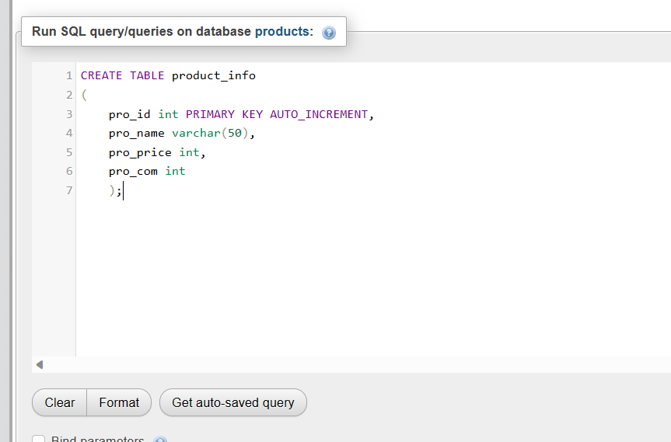

1. Entering details in table:

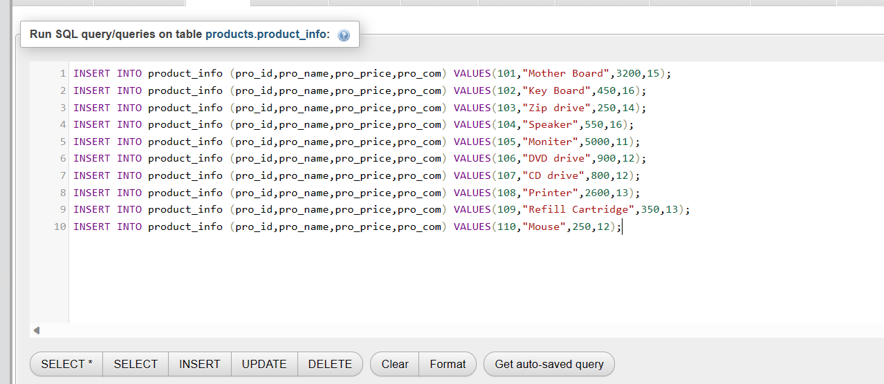

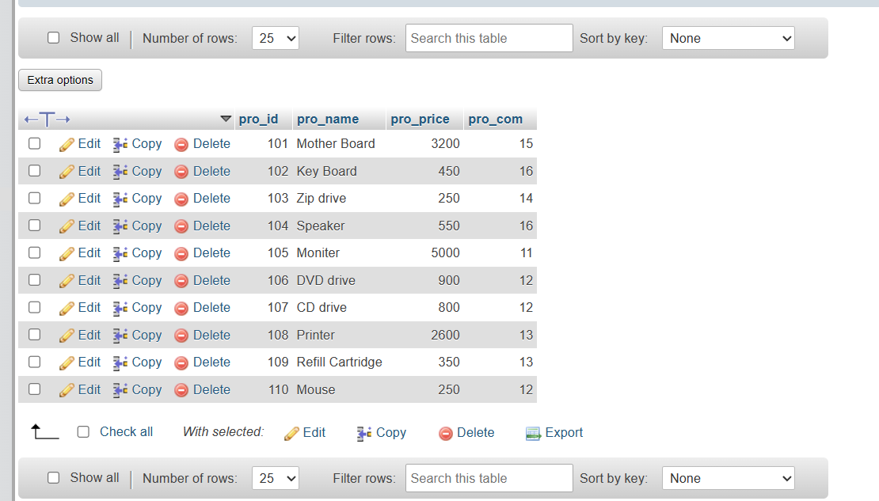

1. Write sql query to find the items whose prices are higher than or equal 250rs.Order the result by product price in descending, then product name in ascending. Return pro_name and pro_price

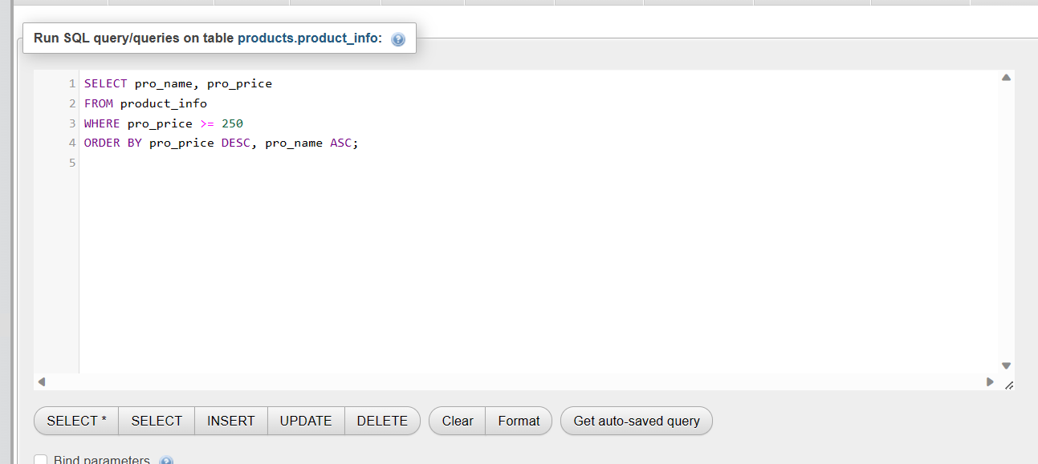

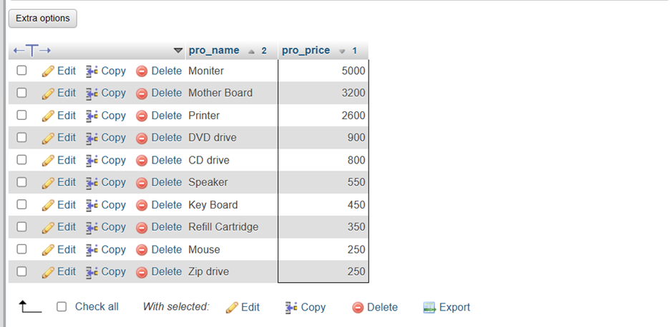

1. Write a sql query to find the cheapest item. Return pro_name and pro_price.

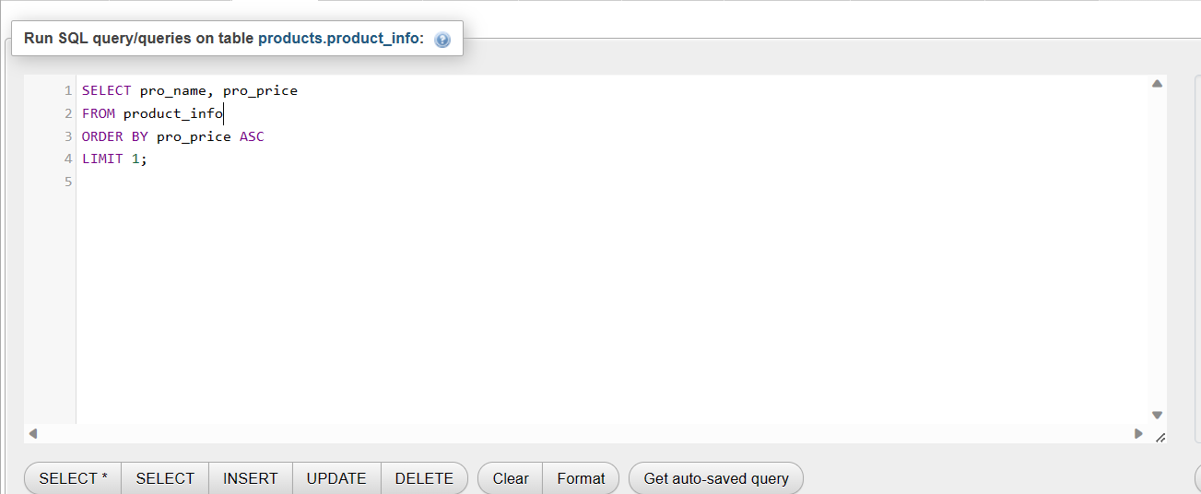

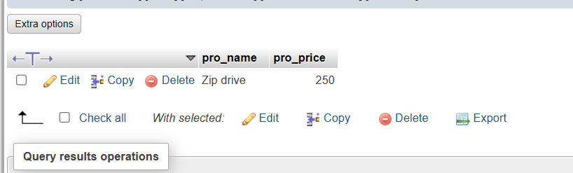

1. Write the sql query to calculate the average price of the items for each company. Return average price and company code

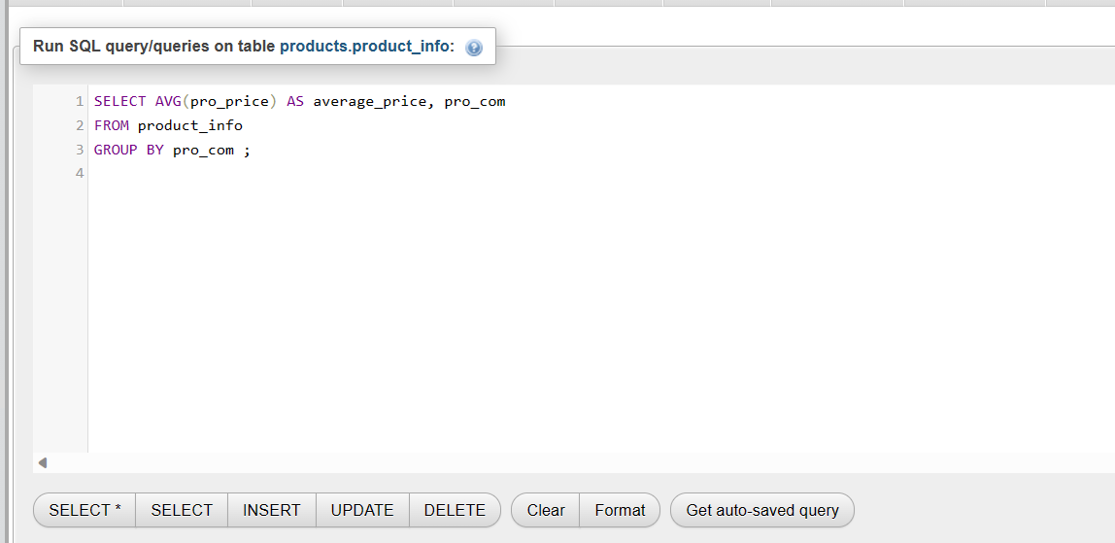

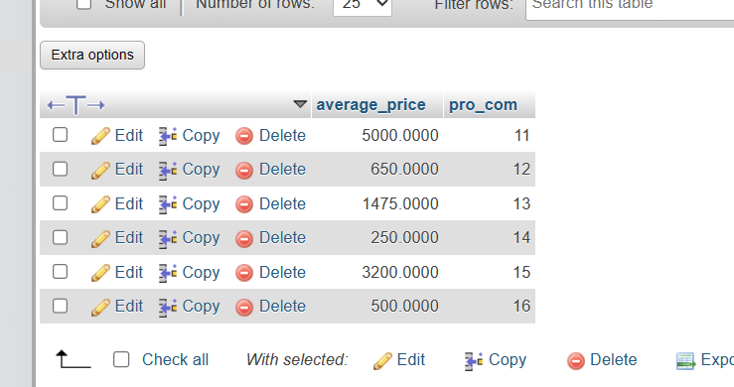

1. Write the sql query to find the average total for all the product mention in the table.

